Insights that can help the company improve its sales

-- Identify top-selling products

SELECT p.productName, SUM(od.quantityOrdered) AS totalQuantitySold

FROM products p

JOIN orderdetails od ON p.productCode = od.productCode

GROUP BY p.productName

ORDER BY totalQuantitySold DESC

LIMIT 5;

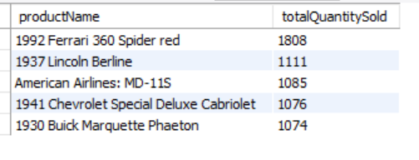

-- Calculate total sales by product category

SELECT p.productLine, SUM(od.priceEach \* od.quantityOrdered) AS totalSales

FROM products p

JOIN orderdetails od ON p.productCode = od.productCode

GROUP BY p.productLine;

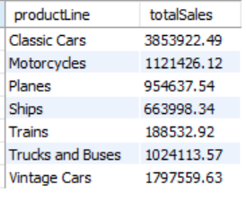

-- Identify high-value customers

SELECT c.customerName, SUM(p.amount) AS totalAmountPaid

FROM customers c

JOIN payments p ON c.customerNumber = p.customerNumber

GROUP BY c.customerName

ORDER BY totalAmountPaid DESC

LIMIT 5;

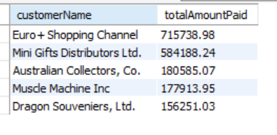

-- Calculate average order value

SELECT AVG(p.amount) AS averageOrderValue

FROM payments p;

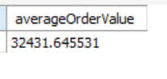

-- Assess regional sales performance:

SELECT c.city, SUM(od.priceEach \* od.quantityOrdered) AS totalSales

FROM orders o

JOIN orderdetails od ON o.orderNumber = od.orderNumber

join customers c on c.customerNumber=o.customerNumber

GROUP BY c.city;

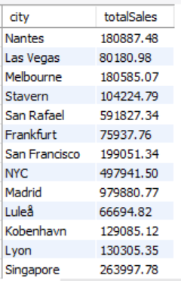

-- Analyze employee sales performance

SELECT e.firstName, e.lastName, SUM(od.priceEach \* od.quantityOrdered) AS totalSales

FROM employees e

JOIN customers c ON e.employeeNumber = c.salesRepEmployeeNumber

JOIN orders o ON c.customerNumber = o.customerNumber

JOIN orderdetails od ON o.orderNumber = od.orderNumber

GROUP BY e.firstName, e.lastName;

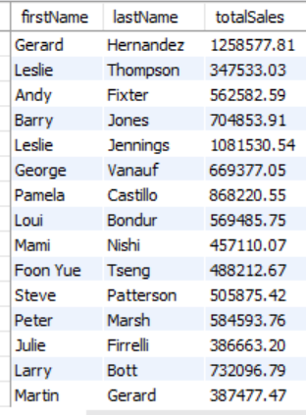

-- Highest selling product line

SELECT

p.productLine,

SUM(od.quantityOrdered) AS totalQuantitySold

FROM productlines pl

JOIN products p ON pl.productLine = p.productLine

JOIN orderdetails od ON p.productCode = od.productCode

GROUP BY p.productLine

ORDER BY totalQuantitySold DESC

LIMIT 1;

